SIT103 DATABASE FUNDAMENTALS
MINIPROJECT PART 2
SUBMITTED BY – JASVEENA-224001588
- Write SQL statements to create all tables in the final normalized ERD in Task 4.2C.
CUSTOMER: CREATE TABLE Customer (
Customer_ID INT AUTO_INCREMENT PRIMARY KEY,
Name VARCHAR(100) NOT NULL,
Age INT NOT NULL,
Email VARCHAR(100) UNIQUE NOT NULL,
Phone_Number VARCHAR(15) NOT NULL
);

DRIVER: CREATE TABLE Driver (
Driver_ID INT AUTO_INCREMENT PRIMARY KEY,
Name VARCHAR(100) NOT NULL,
Email VARCHAR(100) UNIQUE NOT NULL,
Phone_Number VARCHAR(15) NOT NULL,
Car_Number VARCHAR(20) NOT NULL
);
BOOKING : CREATE TABLE Booking (
Booking_ID INT AUTO_INCREMENT PRIMARY KEY,
Booking_Date DATE NOT NULL,
Current_Location VARCHAR(255) NOT NULL,
Destination_Location VARCHAR(255) NOT NULL,
Customer_ID INT,
Driver_ID INT,
FOREIGN KEY (Customer_ID) REFERENCES Customer(Customer_ID),
FOREIGN KEY (Driver_ID) REFERENCES Driver(Driver_ID)
);
PAYMENT : CREATE TABLE Payment (
Payment_ID INT AUTO_INCREMENT PRIMARY KEY,
Payment_Date DATE NOT NULL,
Amount DECIMAL(10, 2) NOT NULL,
Booking_ID INT,
FOREIGN KEY (Booking_ID) REFERENCES Booking(Booking_ID)
);
REVIEW : CREATE TABLE Review (
Review_ID INT AUTO_INCREMENT PRIMARY KEY,
Review_Date DATE NOT NULL,
Description TEXT,
Driver_ID INT,
Booking_ID INT,
FOREIGN KEY (Driver_ID) REFERENCES Driver(Driver_ID),
FOREIGN KEY (Booking_ID) REFERENCES Booking(Booking_ID)
);
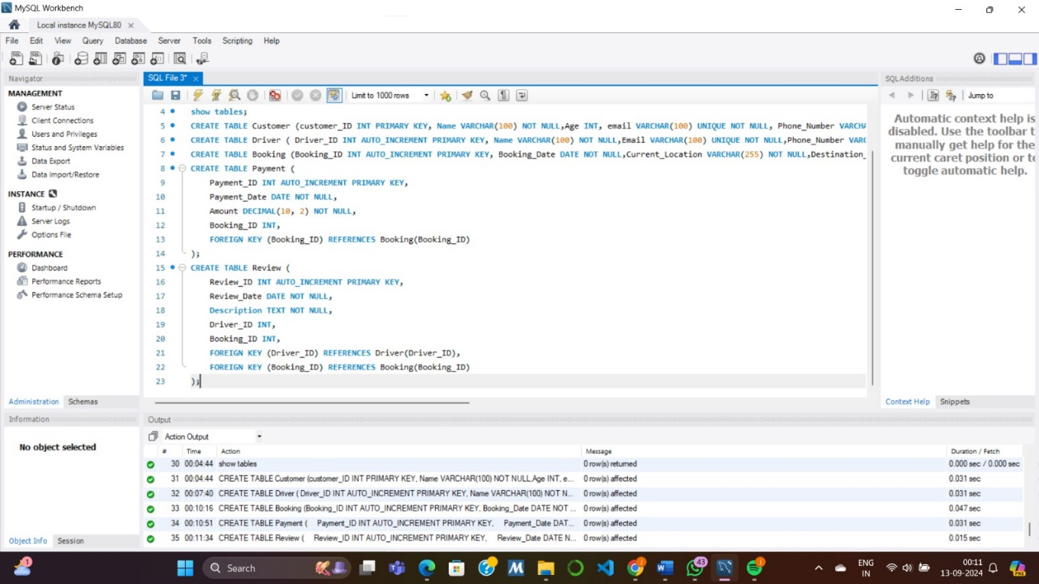
- Insert at least FIVE records in each table using SQL.
CUSTOMER TABLE : INSERT INTO Customer (Name, Age, Email, Phone_Number) VALUES
('John Doe', 30, 'john.doe@example.com', '555-0101'),
('Jane Smith', 25, 'jane.smith@example.com', '555-0102'),
('Emily Davis', 35, 'emily.davis@example.com', '555-0103'),
('Michael Brown', 28, 'michael.brown@example.com', '555-0104'),
('Sarah Wilson', 40, 'sarah.wilson@example.com', '555-0105');

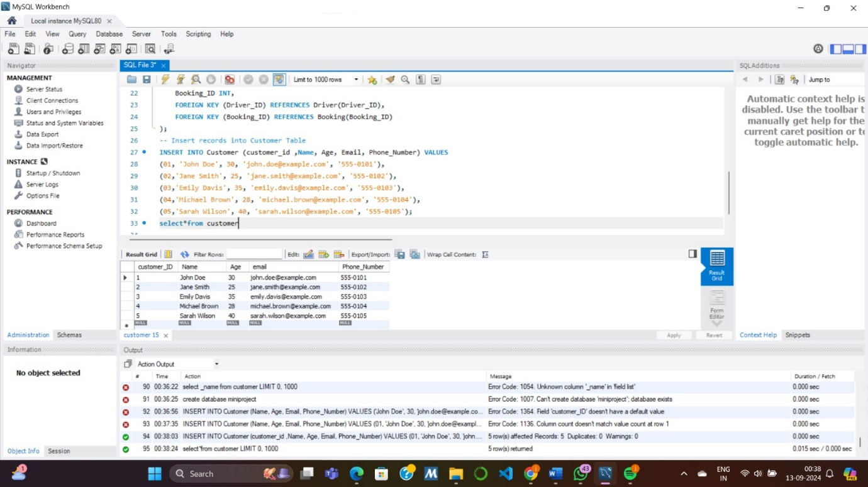

DRIVER TABLE : INSERT INTO Driver (Name, Email, Phone_Number, Car_Number) VALUES
('Alice Johnson', 'alice.johnson@example.com', '555-0201', 'CAR123'),
('Bob Lee', 'bob.lee@example.com', '555-0202', 'CAR124'),
('Charlie Brown', 'charlie.brown@example.com', '555-0203', 'CAR125'),
('David Wilson', 'david.wilson@example.com', '555-0204', 'CAR126'),
('Ella Davis', 'ella.davis@example.com', '555-0205', 'CAR127');

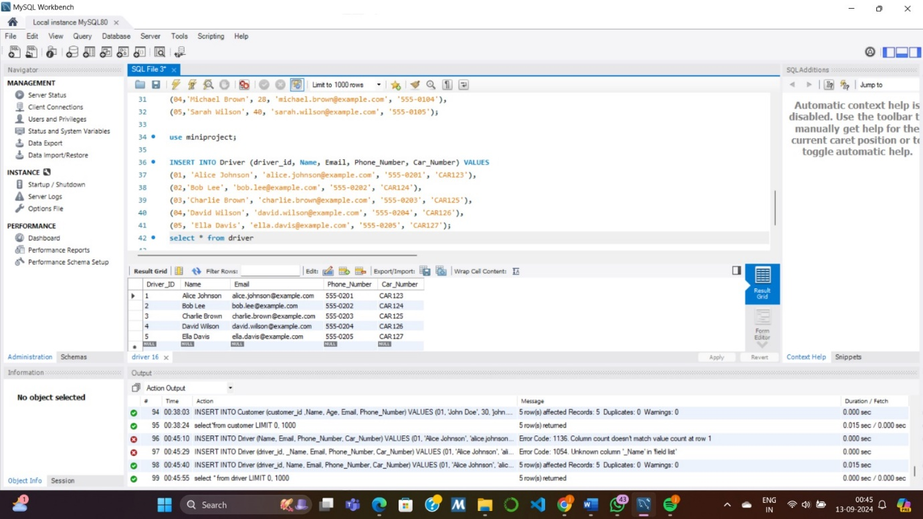

BOOKING TABLE : INSERT INTO Booking (Booking_Date, Current_Location, Destination_Location, Customer_ID, Driver_ID) VALUES
('2024-09-01', '123 Main St', '456 Elm St', 1, 1),
('2024-09-02', '789 Maple St', '101 Pine St', 2, 2),
('2024-09-03', '102 Oak St', '203 Birch St', 3, 3),
('2024-09-04', '204 Cedar St', '305 Walnut St', 4, 4),
('2024-09-05', '305 Spruce St', '406 Pine St', 5, 5);
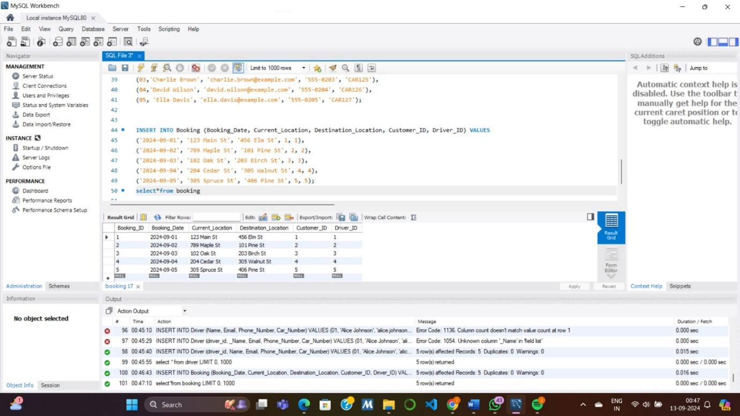

PAYMENT TABLE : INSERT INTO Payment (Payment_Date, Amount, Booking_ID) VALUES
('2024-09-01', 20.00, 1),
('2024-09-02', 25.00, 2),
('2024-09-03', 30.00, 3),
('2024-09-04', 15.00, 4),
('2024-09-05', 40.00, 5);
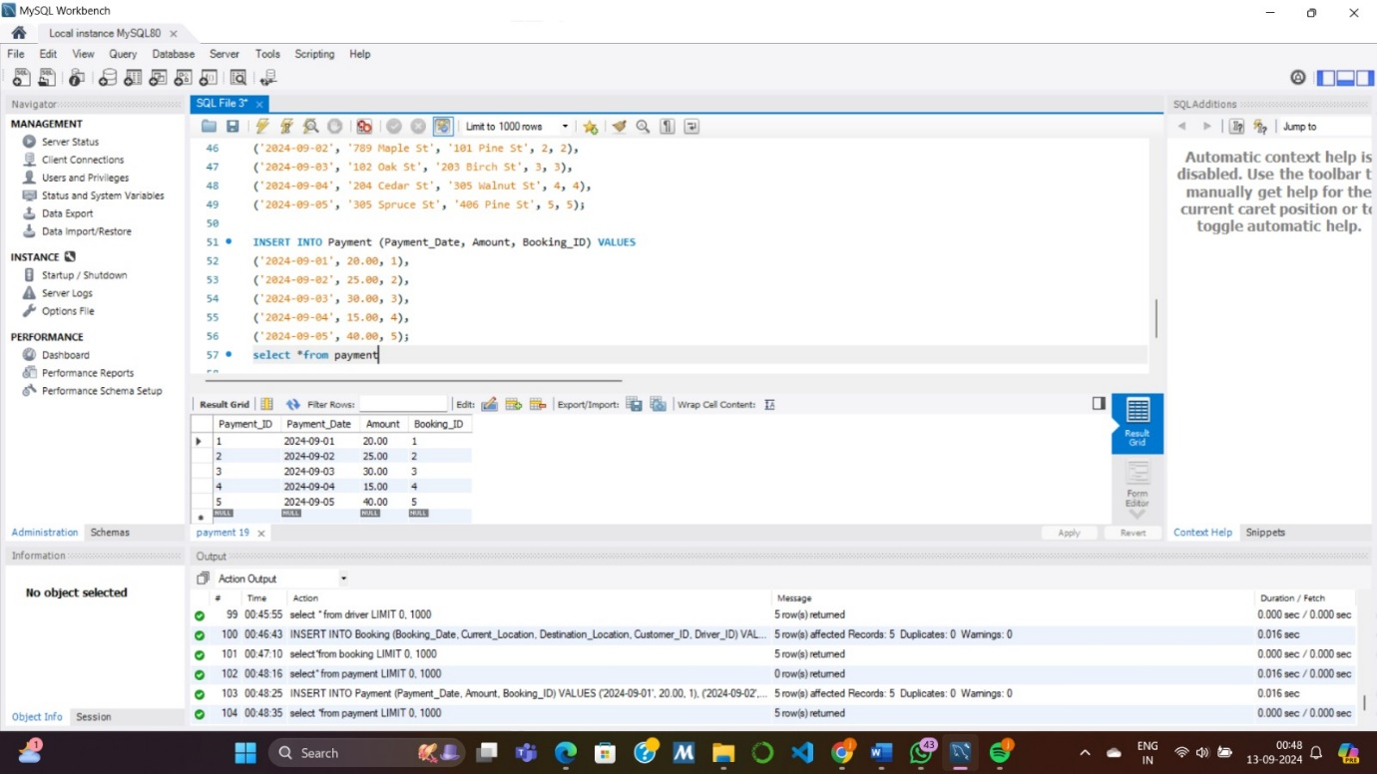

REVIEW TABLE : INSERT INTO Review (Review_Date, Description, Driver_ID, Booking_ID) VALUES
('2024-09-02', 'Great service!', 1, 1),
('2024-09-03', 'Very punctual.', 2, 2),
('2024-09-04', 'Friendly driver.', 3, 3),
('2024-09-05', 'Comfortable ride.', 4, 4),
('2024-09-06', 'Will use again.', 5, 5);
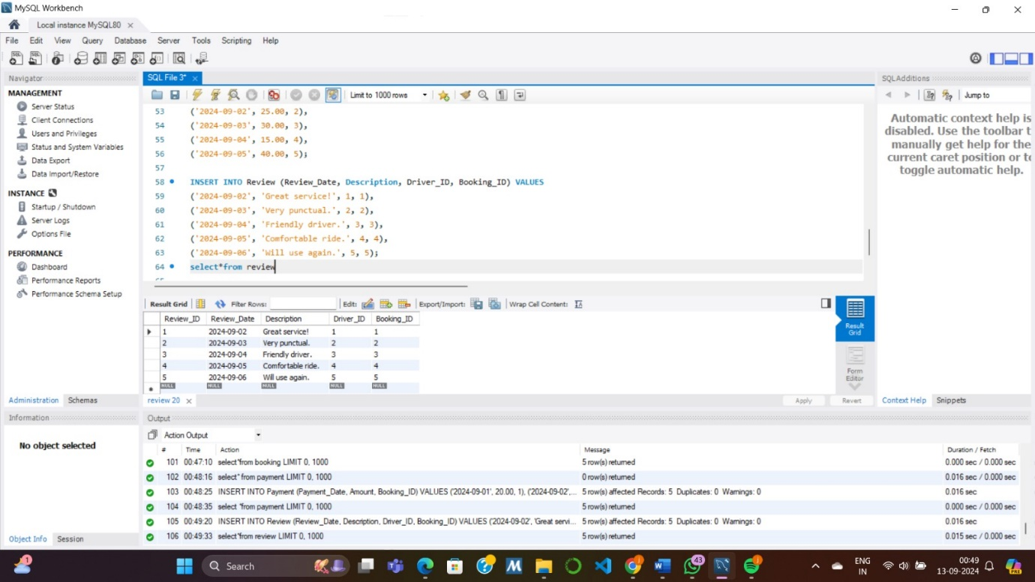
3. Write and run an SQL statement to add one additional column (attribute) in any one of the existing tables
with a default value.
Alter table Customer ADD COLUMN `Preferred_Payment_method` varchar(20) default "Cash";
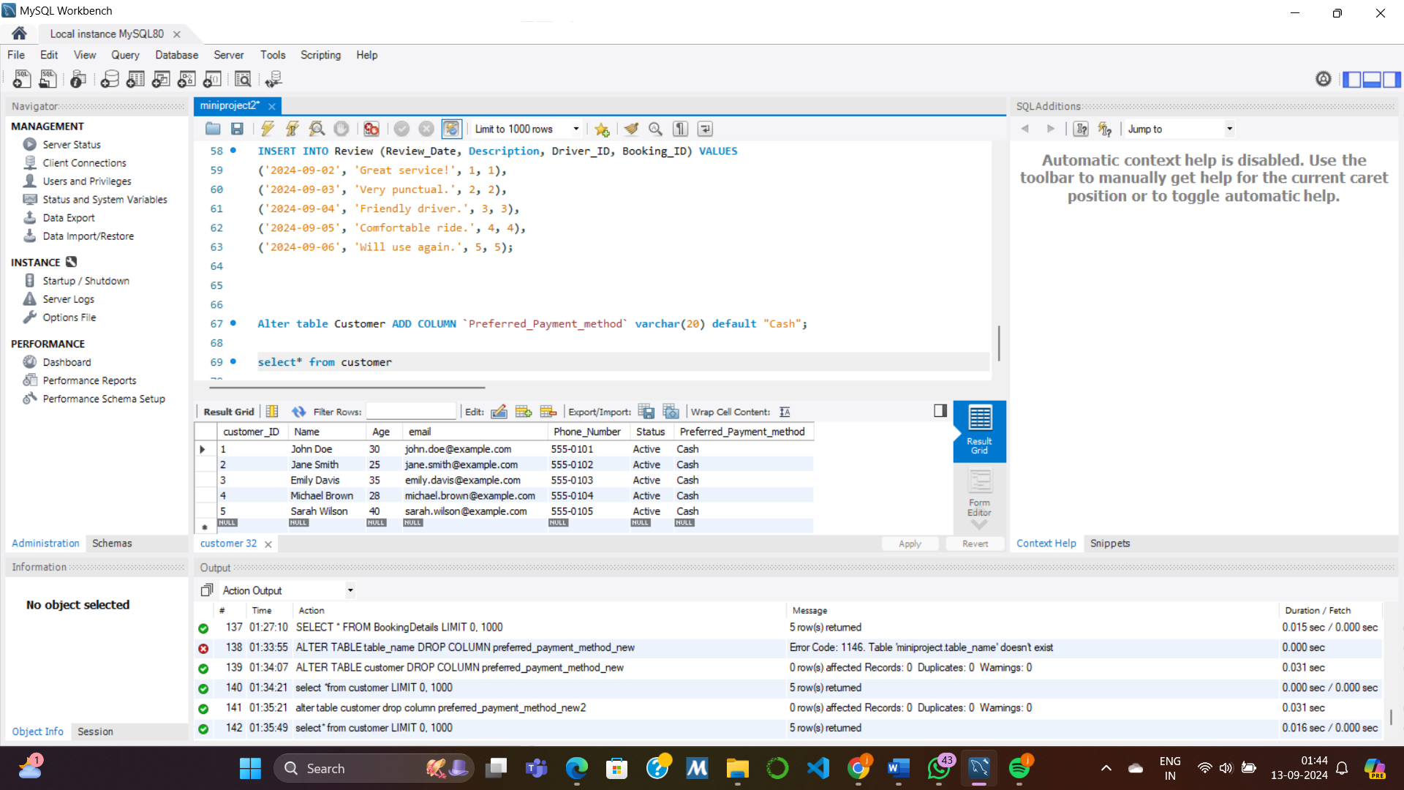
4. Write and run an SQL statement to update the default value of the newly added column to a different value
for certain rows based on a condition using any other column.
Alter table customer Add column Preferred_payment_method_new varchar(30) default ( case when age

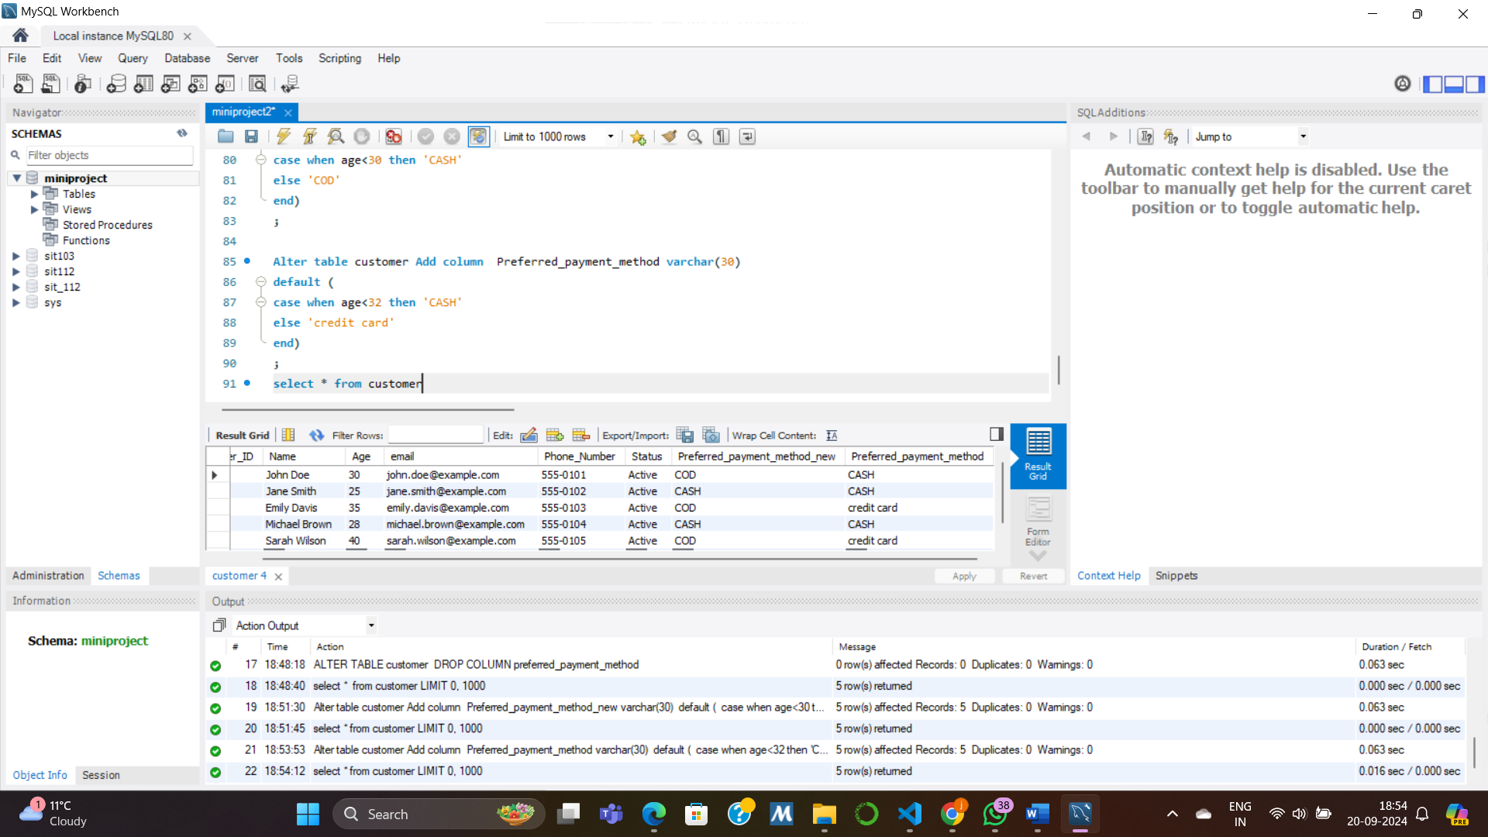
5. In this section, you are required to write SQL queries to interact with the database you implemented. Answer
each SQL question in this section with the following:
- Write an SQL query to demonstrate the use of SELECT with INNER JOIN and ORDER BY.
SELECT b.Booking_ID, c.Name AS Customer_Name, d.Name AS Driver_Name, b.Booking_Date
FROM Booking b
INNER JOIN Customer c ON b.Customer_ID = c.Customer_ID
INNER JOIN Driver d ON b.Driver_ID = d.Driver_ID
ORDER BY b.Booking_Date;

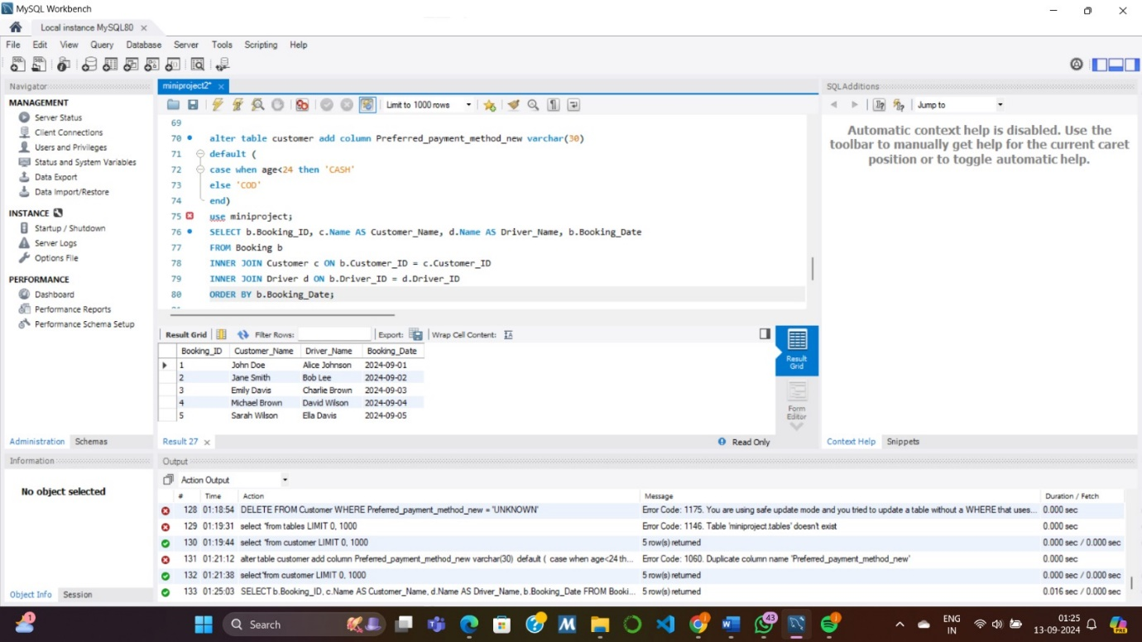
- Write an SQL query to demonstrate the use of SELECT with WHERE and IN.
SELECT * FROM Customer
WHERE Customer_ID IN (1, 3, 5);
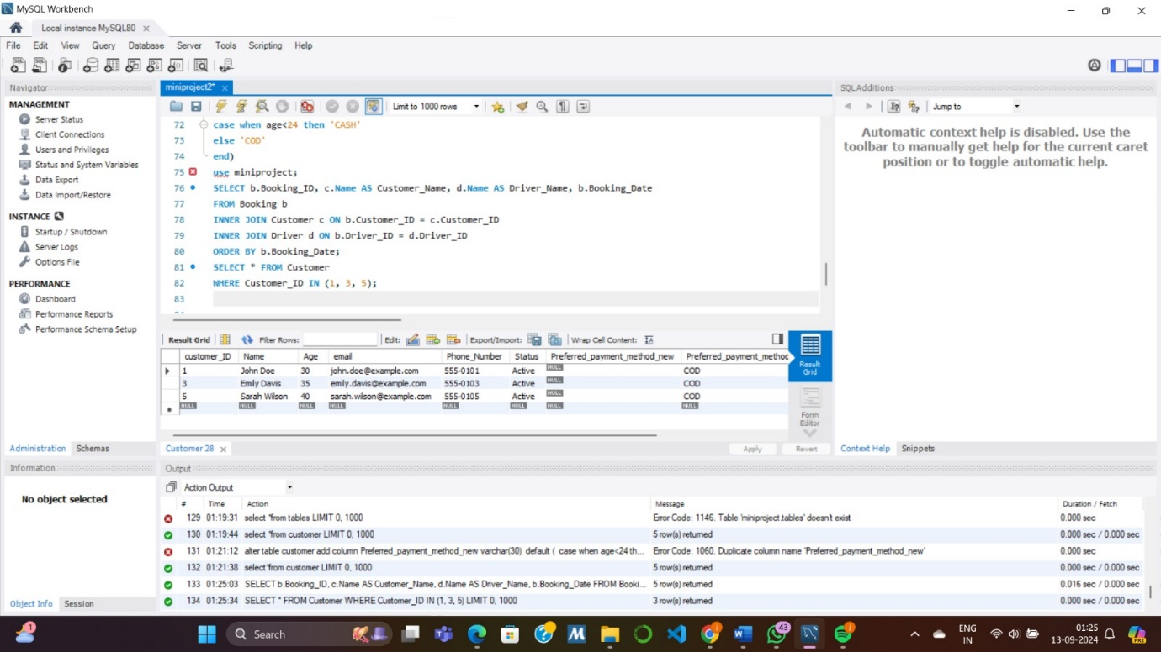
- Write an SQL query to demonstrate the use of at least one DATE function.
SELECT Booking_Date, COUNT(*) AS Total_Bookings
FROM Booking
GROUP BY Booking_Date;
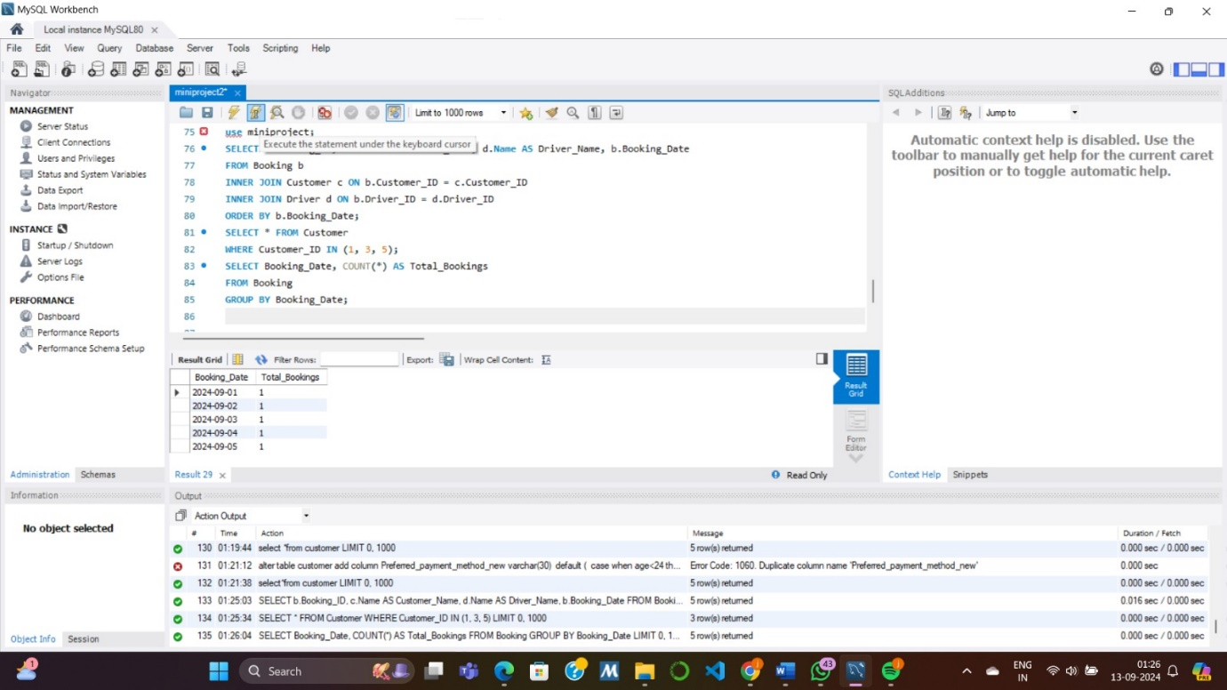
d) Write an SQL statement to create a VIEW using a SELECT statement with a JOIN. Provide the statement
to create the VIEW you want and demonstrate the output of the VIEW using ‘SELECT * FROM
<viewname>;’

CREATE VIEW BookingDetails AS
SELECT b.Booking_ID, b.Booking_Date, c.Name AS Customer_Name, b.Current_Location, b.Destination_Location
FROM Booking b
INNER JOIN Customer c ON b.Customer_ID = c.Customer_ID;
